Faculty of Computing
The Islamia University of Bahawalpur



Software Design Document

AI-Based Facial Emotion Recognition System

Submitted by
Abdullah Waqar
S23BINFT1M01138

Submitted to
Mr Munawar Ahmad

Summary
This project develops an AI-based Facial Emotion Recognition System capable of detecting human emotions from facial expressions in real time. The system utilizes a Flutter-based mobile application to capture facial images through the smartphone camera and transmit them to a backend server for processing. The backend, implemented using Flask or FastAPI, integrates with a Convolutional Neural Network (CNN) model developed using TensorFlow, Keras, and OpenCV. The model is trained on facial emotion datasets such as FER2013 and CK+ to recognize emotions including happiness, sadness, anger, surprise, and neutrality. After analyzing the facial features, the system predicts the corresponding emotion along with a confidence score. The prediction results are then returned to the mobile application and displayed to the user in real time, providing an intelligent and interactive AI-powered emotion analysis platform.

Table of Content

1. Introduction 4
1.1. Purpose of SDD 4
1.2. Scope 4
2. Application Architecture 5
2.1. Architectural Overview 5
2.2. High-Level Architecture Components 6
2.3. Architecture Flow 7
3. User Interface Design 9
3.1. UI Overview 9
3.2. User Interaction Flow 9
3.3. Sample UI Conversation 10
3.4. UI Design Characteristics 10
4. Design Diagrams 11
4.1. Class Diagram 11
4.2. Architecture Diagram 12
4.3. Sequence Diagram 12
4.4. Component Diagram 13
4.5. Security Diagram 13
5. Scalability and Maintainability 14
6. Conclusion 14

1. Introduction

The system is designed to identify emotions such as happiness, sadness, anger, surprise, and neutrality using deep learning techniques and computer vision.

1.1 Purpose of SDD

The purpose of this Software Design Document (SDD) is to describe the design and architecture of the AI-Based Facial Emotion Recognition System. This document provides detailed information regarding system architecture, user interface design, software components, workflows, security mechanisms, scalability considerations, and implementation strategies.
The SDD serves as a reference for developers, testers, project supervisors, and future maintainers to understand how the system is structured and how different modules interact to achieve real-time facial emotion recognition.

1.2 Scope

The AI-Based Facial Emotion Recognition System is designed to detect and classify human emotions from facial images captured through a mobile application. The system uses deep learning techniques, computer vision, and mobile technologies to provide emotion predictions in real time.
The scope of the project includes:
- Capturing facial images through a Flutter mobile application.
- Sending images to a backend API.
- Face detection using OpenCV.
- Image preprocessing.
- Emotion classification using a CNN model.
- Returning emotion predictions and confidence scores.
- Displaying results in a user-friendly interface.
- Supporting future enhancements such as real-time video emotion recognition.

2. Application Architecture

The system follows a modular client-server architecture consisting of a Flutter frontend, backend API server, preprocessing layer, and CNN-based emotion recognition engine.

2.1 Architectural Overview

The system follows a three-tier architecture consisting of:

Presentation Layer
- Flutter Mobile Application
- User interaction
- Camera access
- Result visualization

Application Layer
- Flask/FastAPI Backend
- Request handling
- Image processing
- Communication with AI model

Intelligence Layer
- CNN-based Deep Learning Model
- Emotion classification
- Confidence score generation
The architecture separates concerns and improves maintainability, scalability, and performance.

2.2 High-Level Architecture Components

1. Mobile Application (Flutter)
- Camera integration
- Image capture
- API communication
- Displaying prediction results
- Error handling

2. Backend Server (Flask/FastAPI)
- Receive image requests
- Validate image data
- Face detection
- Image preprocessing
- Model invocation
- Response generation

3. Emotion Recognition Model
- Analyze facial expressions
- Classify emotions
- Generate confidence scores
Supported emotions:
- Happy
- Sad
- Angry
- Surprise
- Neutral

4. Dataset Layer
Training datasets:
- FER2013
- CK+
Used for model training and validation.

ER Diagram

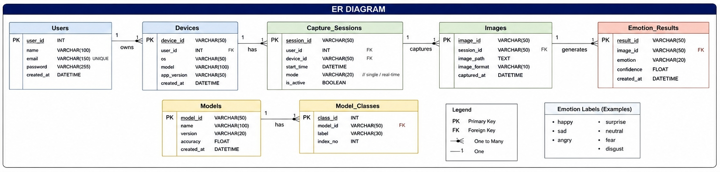
Shows the database design and relationships between entities such as users, images, sessions, models, and emotion prediction results.

2.3 Architecture Flow
The system follows the workflow below:
- The user opens the Flutter application.
- User captures facial image.
- Application sends image to backend API.
- The backend receives images.
- OpenCV detects face regions.
- Image preprocessing is performed.
- The processed image is passed to the CNN model.
- CNN predicts emotion.
- Confidence score is calculated.
- The backend returns a response.
- Flutter app displays prediction and confidence.

Activity Diagram

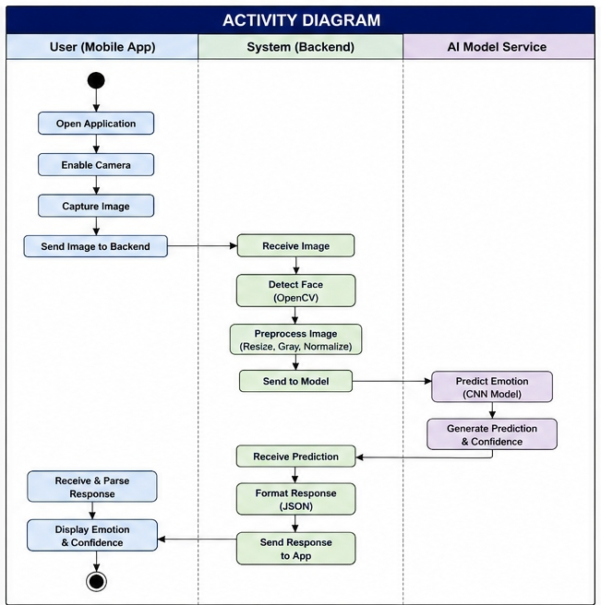
Illustrates the step-by-step workflow of capturing an image, processing it through the AI model, and displaying the predicted emotion.

3. User Interface Design

3.1 UI Overview
The user interface is designed to be simple, intuitive, and mobile-friendly.
Main Screens:

Home Screen
- App logo
- Camera preview
- Capture button

Processing Screen
- Loading animation
- Analysis status

Result Screen
- Detected emotion
- Confidence percentage
- Emotion emoji/icon
- Retake image option

3.2 User Interaction Flow
- User launches application.
- Camera preview opens.
- User captures facial image.
- The image is uploaded to the backend.
- The system analyzes the image.
- Prediction is returned.
- The result is displayed.
- Users may retake the image.

3.3 Sample UI Conversation
System: Welcome to Emotion Detection App
User: Captures Image
System: Processing Image...
System: Emotion Detected: Happy 😊
System: Confidence Score: 92%
User: Capture Another Image
System: Camera Ready

3.4 UI Design Characteristics
The interface should exhibit:

Simplicity
Minimal screens and controls.

Responsiveness
Fast response across devices.

Accessibility
Readable text and clear buttons.

Consistency
Uniform color scheme and layouts.

Feedback Mechanism
Loading indicators and result notifications.

4. Design Diagrams

4.1 Class Diagram

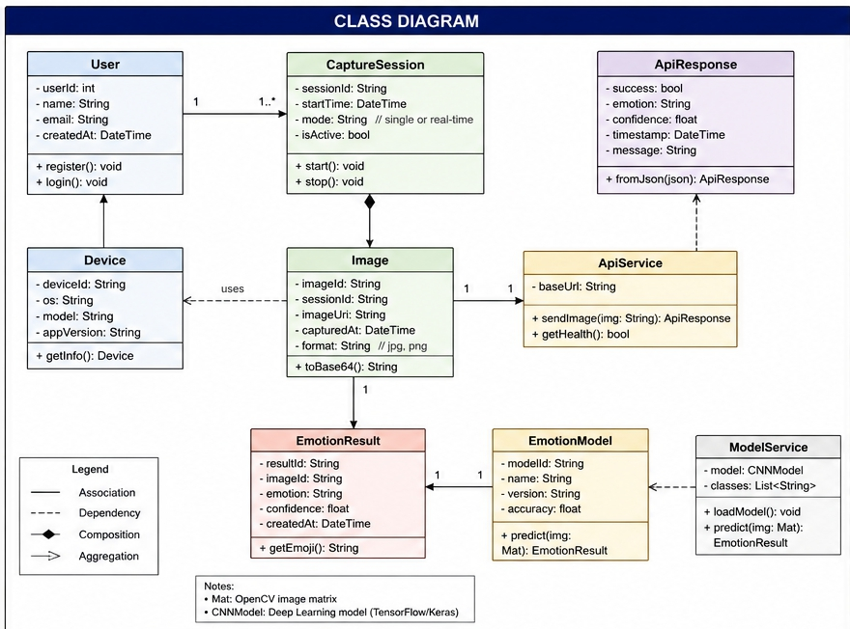

Represents the architecture of the system by showing classes, attributes, methods, and relationships involved in emotion detection.

4.2 Architecture Diagram
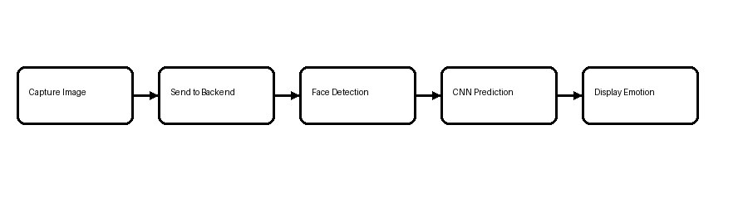

4.3 Sequence Diagram

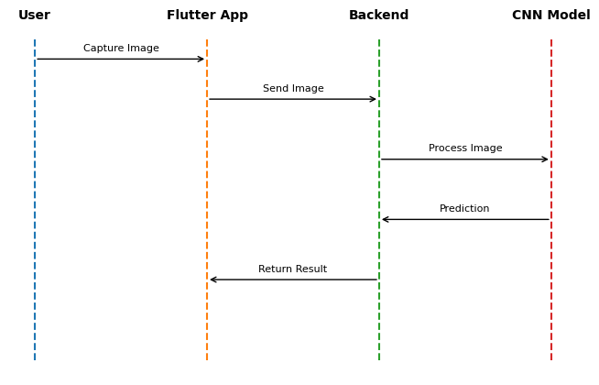

4.4 Component Diagram

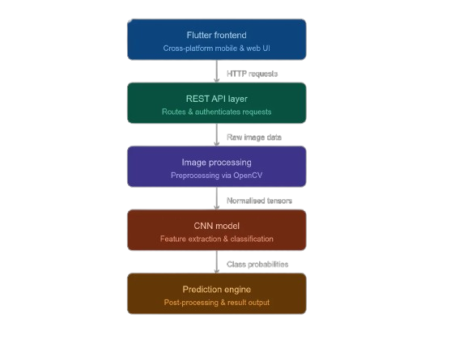

4.5 Security Considerations

- HTTPS-based API communication
- Restricted backend access
- No unauthorized image storage
- Secure request validation

5. Scalability and Maintainability
The system is designed with scalability and maintainability in mind.

Scalability
- Backend APIs can be deployed on cloud servers.
- Multiple API instances can be used through load balancing.
- Model serving can be containerized using Docker.
- Future support for video stream analysis.
- Support for thousands of concurrent requests.

Maintainability
- Modular architecture separates frontend, backend, and AI model.
- Individual modules can be upgraded independently.
- Easy replacement of CNN model with advanced architectures.
- Clear API contracts improve maintainability.
- Documentation supports future development.

Future Enhancements
- Real-time video emotion recognition.
- Multi-face detection.
- Emotion analytics dashboard.
- User history tracking.
- Cloud-based model deployment.

6. Conclusion
The AI-Based Facial Emotion Recognition System provides an intelligent and scalable solution for recognizing human emotions from facial expressions. The system integrates Flutter, Flask/FastAPI, OpenCV, TensorFlow, and CNN-based deep learning models into a unified architecture capable of delivering real-time emotion predictions.
The proposed design ensures high usability, modularity, scalability, and maintainability while providing a strong foundation for future enhancements. Through effective integration of mobile computing, computer vision, and artificial intelligence, the system demonstrates a practical implementation of modern machine learning technologies in real-world applications.
This SDD is based on the requirements and architecture defined in the project's SRS document.

